Psalm 2:8 Ask of Me, and I will give You The nations for Your inheritance, And the ends of the earth for Your possession.

Prayer Guide for Jasper County

Connect Pray Now – A prayer initiative of the Global Net.

Prayer is foundational to accomplishing the urgent task of reaching our communities and the world for Christ. Connect – Pray Now is launched as part of the prayer advocacy focus of The Global Net.

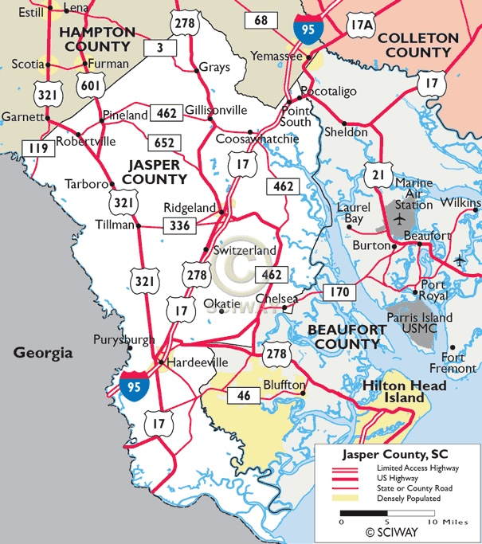
Founded in 1912 Jasper county covers 699 square miles and is the home of 30,000 plus people living in 44 cities, towns and rural communities.

Jasper county was named after Revolutionary War hero Sergeant William Jasper (1750-1779). The county was home to one of the signers of the Declaration of Independence, Thomas Heyward, Jr. (1746-1809) and Henry Martyn Robert (1837-1923), author of Robert's Rules of Order.

Prayer focus: The Church

Luke 10:2 “…the harvest truly is great…”

Scripture:

John 17: 20-21 "I do not pray for these alone, but also for those who will believe in Me through their word; that they all may be one, as You, Father, are in Me, and I in You; that they also may be one in Us, that the world may believe that You sent Me.

Prayer prompt:

Pray for the unity of believers in Jasper County. Ask the Lord to bring His people together to seek revival and spiritual awaking.

According to statics only 29.5% of the residence of Jasper county identify as being religious.

Crime is ranked on a scale of 1 (low crime) to 100 (high crime). Jasper County violent crime rate is 39.2 (the US average is 22.7)

The reason so many churches are prayerless, dead, and gripped by confusion and internal dissention is not because the Word of God is not being preached, although that is the case for some; but rather because they do not have an ear to hear what the Spirit is saying. Their spiritual perception has been dulled by their stubborn refusal to live surrendered lives. In other words, people have chosen to live by their own code of convenience rather than in the shadow of the cross.

Ephesians 3:21 “to Him be glory in the church by Jesus Christ to all generations, forever and ever. Amen.”

The highest purpose of the church is to bring glory to God. When the church is bringing God glory, the radiance of His glory is dispelling the darkness of sin and hopelessness.

When the church is bringing God glory the power of the gospel is sounding forth in the power of the Holy Spirit and stronghold that keep people lost are crumbling.

When the church is bringing God glory people are experiencing His righteousness and grace and through forgiveness of sin and the joy of a personal relationship with Jesus Christ.
Prayer focus: The Church

Scripture:

Isaiah 44:3 For I will pour water on him who is thirsty, And floods on the dry ground; I will pour My Spirit on your descendants, And My blessing on your offspring;

Prayer prompt:

Pray that God will make His people thirsty to know Him more intimately.

Prayer Focus: Labors for the harvest

Scripture:

Luke 10: 2 Then He said to them, "The harvest truly is great, but the laborers are few; therefore pray the Lord of the harvest to send out laborers into His harvest.

Prayer Prompt:

Ask the Lord of His harvest to send laborers into His harvest in Jasper county. Pray that God will raise up a unified army of intercessors who will do battle in the spiritual realm against the spiritual hosts of wickedness who work to keep people lost.

II Corinthians 4: 4 “Whose minds the god of this age has blinded, who do not believe, lest the light of the gospel of the glory of Christ, who is the image of God should shine on them.”

Through prayer God will break the spiritual strongholds that keep people blind to the message of the gospel.

Scripture:

Proverbs 29:2 When the righteous are in authority, the people rejoice; But when a wicked man rules, the people groan.

Prayer prompt:

Pray that the men and women who are in leadership will have the heart and will to do what is right. Ask the Lord to give wisdom and patience to the leaders of Jasper County. Pray that they will be people of faith and integrity.

Focus: City, Town and County Officials

Prayer Strategy

- Use a map of Jasper County to pray systematically for each city and town and the surrounding communities.

- Write down the names of pastors you know and schedule regular times to pray for them. Search out prayer themes from Scripture to assist you in your intercession. Here are a few examples: Ephesians 1: 15-23; Philippians 1:9-11

- Involve a group in your church to help you pray. Assign them a school, county council member or law enforcement officer to pray for.

- Prayerfully select a town or city and plan a prayer walk.

- Start a Connect Pray Now intercessory prayer team. Contact Wayne Golden ewaynegolden@gmail.com or call: 803 378 3872 for more information or to schedule a training event.

- Prayerfully select a town or city and plan a prayer walk.

- Start a Connect Pray Now intercessory prayer team. Contact Wayne Golden ewaynegolden@gmail.com or call: 803 378 3872 for more information or to schedule a training event.

